# Lab 1.03 - Printing & Variables

## Part 1 - Printing Practice

Practice typing out some statements in the editor part of the IDE, then hit “Run” at the top of the screen:

|  |  |  |
| --- | --- | --- |
| Expression | Expected Output | Did anything unexpected happen? |
| print("1") |  |  |
| print(1) |  |  |
| print(1 + 2) |  |  |
| print("1" + "2") |  |  |
| print("this" + " " + "is" + " " + "a" + " " + "sentence" + ".") |  |  |

## SNAP Flashback - Print Comparison

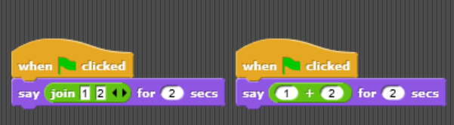

Code

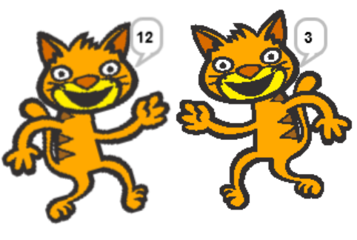

Image

## Part 2 - Variables Practice

### 1. In your Console

#### Type and run the following

animal = "dogs"  
print(animal + " are really cool.")

### In your Notebook

#### Respond to the following

1. What happens?
2. How would you make the program print out “cats are really cool” instead?

### 2. In your Console

#### Type and run the following code

print(dogs + " are cool.")

### Continue In your Notebook

#### Respond to the following questions

1. What output does this produce?
2. Why does this happen?

### 3. In your Console

#### Rewrite the following Snap! Program in Python

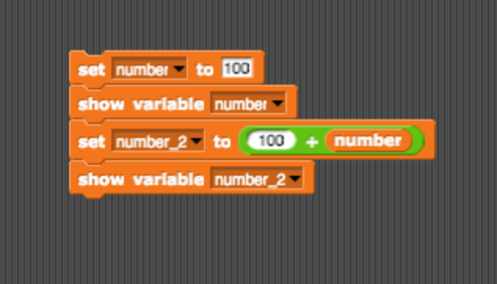

snap_blocks_variables

## Part 3 - Four Fours

### The four fours challenge

Using four 4’s and any operations, try to write equations that have the numbers from 0 to 4 as the answer. You should use Python’s arithmetic operations:

* + addition
* - subtraction or negation
* * multiplication
* / division
* ( ) parentheses for grouping
* ** power

You may also use 44 or 4.4, which count as two fours, or .4, which counts as one four. For example, one solution for zero is:

print("Zero is", 44-44)

Can you find a different solution?

Here are what the results, but not the source code, will look like. (Note: answers may have trailing zeros if floating point arithmetic is used which is fine, i.e. 1 may be displayed as 1.0)

Zero is 0  
One is 1  
Two is 2  
Three is 3  
Four is 4

## Bonus

Print the output below, but only using **one** line of code. Feel free to use online resources.

Wow!  
This is on a new line!

## Bonus 2

Can you find four fours for 5 to 10?